**Predicting age of image by CNN**

**Report**

**Abstract:**

**Introduction:** This project will predict the age by the face image and see if it can correctly predict the age of a person by his image.

**Dataset:**

The dataset is from **Kaggle** and this CSV includes of **27305** rows and **5** columns, The description of each field is as below:

* Age.
* ethnicity.
* Gender.
* img_name.
* pixels.

**Communication:**

* **Train test spliting of data:**

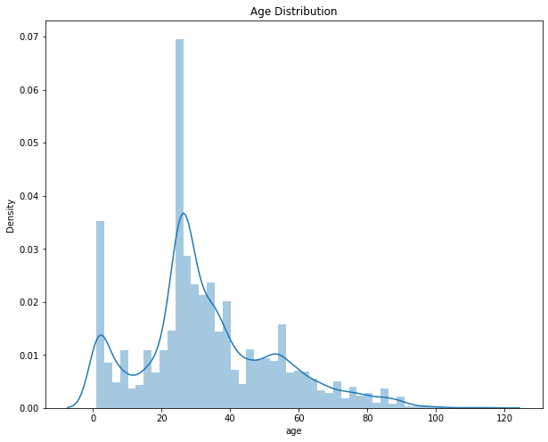

**Conclusion:**

In this project we will improvement the models and add more details in this project**.**